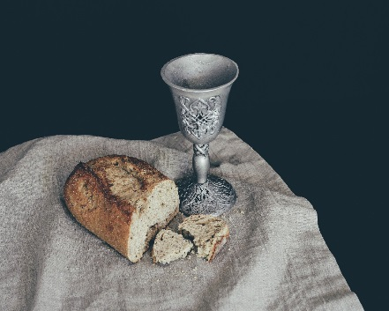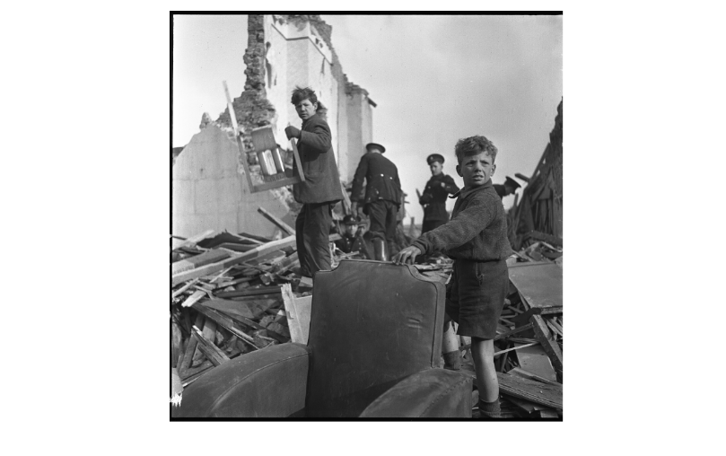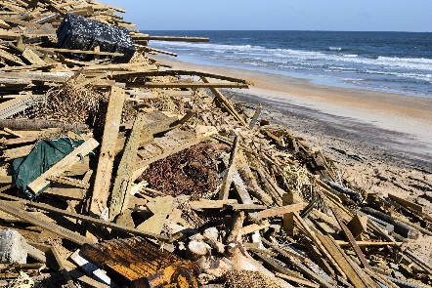



# The Doctor of Ministry Program *starts* February 2021

## **University of Dubuque Theological seminary**

## inFORMATION: [ksCHWEEN@DBQ.EDU](mailto:ksCHWEEN@DBQ.EDU) 563.589.3691

*Throughout its history, Christ’s church has confronted crises,*

*both internal and external, both institutional and individual.*

In this Doctor of Ministry cohort, we will explore ways the church has addressed crises in the past to develop the theological perspectives and pastoral skills necessary to equip congregations and their members in the present to witness to the hope of the gospel in times of crisis.

# **Crisis and**

# **the ChurcH**

**Ecclesiastical and Pastoral Responses**



**— Cohort Leaders —**

Dr. Bradley Longfield

*Professor of Church History* UDTS

Dr. Beth McCaw

*Associate Professor of Ministry*,UDTS

*Presbytery Leader*, Glacier Presbytery (PCUSA)

