The Master of Arts
In Reformed Theology

The University of Dubuque Theological Seminary (UDTS) and Theology Matters (TM) are proud to co-offer a degree will focus on a Reformed understanding of the Scriptures and study of classic texts and practices valued by the Reformed tradition. Instructors include members of the faculty of UDTS and pastor-scholars whose knowledge has been tested in the academy and significant pastoral ministry.

The Master of Arts in Reformed Theology is a 36-credit degree offered in a hybrid format that includes both online and face-to-face learning. The degree will prepare Christian disciples for service in the church and world in ordained or non-ordained positions and strengthen the ministries of those already serving as pastors, commissioned lay pastors (CLPs), elders, deacons, and lay teachers or those transferring into a Reformed or Presbyterian denomination.

The degree will also provide a foundation for those pursuing doctoral work in theology, philosophy, church history, biblical studies, and various other fields in the humanities.

Our Goals

Few seminaries, divinity schools, or graduate programs in the United States today offer a degree in theology from the mainstream of the Reformed tradition and for leaders serving or seeking to serve congregations of this same tradition. Focusing on contemporary and classic texts and practices valued by the Reformed tradition and drawing upon current UDTS faculty and pastor-scholars whose knowledge and wisdom has been tested in both the academy and in pastoral ministry, this program is designed to enable students to:
1) Develop a sympathetic grasp of the history and core commitments of the Christian tradition, particularly as articulated in the Reformed tradition, in order to be an effective teacher and practitioner of the Christian faith.

2) Develop the ability to engage critically and constructively with the contents of the Christian tradition, especially as reflected in the Reformed tradition, for the sake of growing faith and effective mission and ministry.

Our Mission

The University of Dubuque Theological Seminary and Theology Matters are working together in offering this degree program to gather students and faculty in gratitude and faithfulness to be reformed according to the Word of God, grow in the Church's biblical faith in the Triune God, excel in theological education and scholarship, and live as faithful stewards of God's gifts, engaging the changing needs of the Church and World.

The program seeks to equip, encourage, instruct, and inspire leaders of Reformed and Presbyterian churches and of the broader Christian community through the clear and coherent articulation of theology that is reformed according to God’s Word and bears witness to the truth of Jesus Christ.

Together we seek to raise up a new generation of leaders, especially for congregations in the Reformed–Presbyterian tradition.

Required Courses:

Introduction to the Reformed Tradition
Interpretation of the Old Testament in
the Reformed Tradition
Interpretation of the New Testament in
the Reformed Tradition
Reformed Theology I
Reformed Theology II
Capstone Project in Reformed Theology

Elective Courses:

Early & Medieval Church History
Reformation & Modern Church History
Presbyterian History and Confessions
American Puritanism through Edwards
The Theology of Augustine
The Theology of John Calvin
The Theology of Karl Barth
The Theology of T.F. Torrance
Leading Christian Worship
Foundations of Preaching
The Psalms in Christian Worship
Preaching from the Old Testament
Preaching from New Testament Books
Proclaiming the Word
Expository Preaching
Worship in the Reformed Tradition
& More

“The MART program has given me the equipment to be able to preach the Word, teach the Word, and to be able to impart the Word to the next generation.”
- Daniel Gorenberg ‘25

“I wanted to join the MART program to be part of a tradition, because in tradition, God is on the move…”
- Andrew Goins ’25

“Every good teacher wants their students to surpass them, and I very much get that from Calvin, Luther, Augustine and Barth… I feel empowered to take these lessons, to learn, to listen, to ask questions and to see where improvements could be made. This is the truest way of responding to the love these teachers had for us, and the best way to respond to the love from the Lord Jesus Himself.”
- Amy Kosari ’25

For More Information About Or To Apply To The
MASTER OF ARTS IN
REFORMED THEOLOGY
please contact Dr. Richard E Burnett,
Executive Director of Theology Matters and
Director of the M.A.R.T.
at 864-378-5416 or email him at
rburnett@dbq.edu

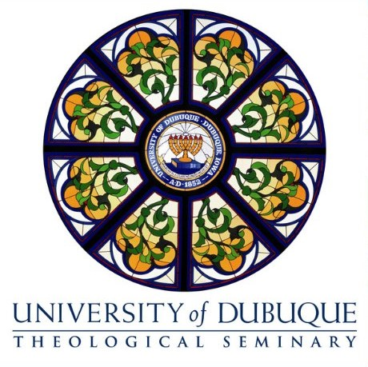
^{And}
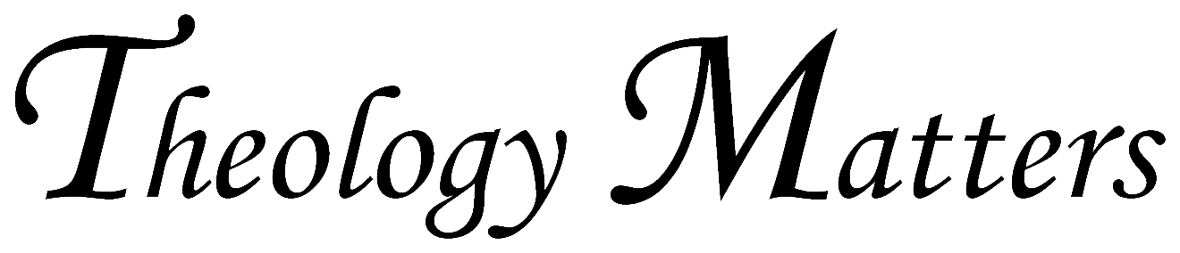

^{Master of Arts}
^{in}
^{Reformed Theology}

