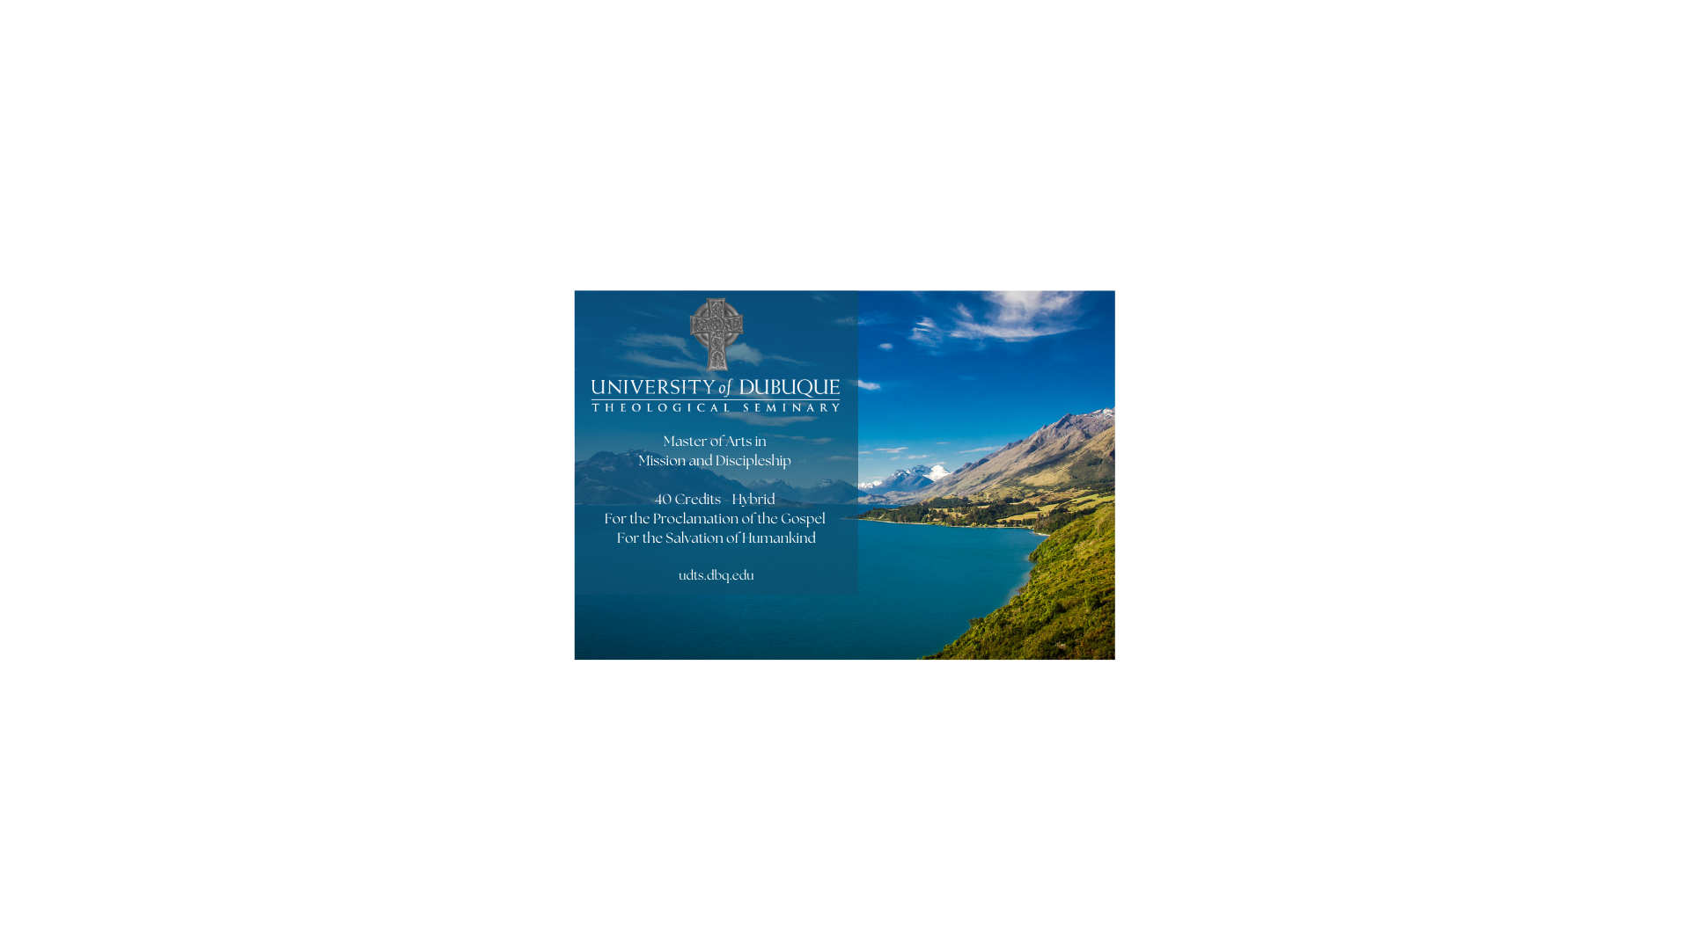

**Following Jesus, Walking in the Spirit,**

**Joining God’s Mission**

**The Master of Arts in Mission and Discipleship (MAMD)** trains followers of Jesus to empower others to join the mission of God in a variety of callings. This flexible degree includes four or more electives, courses in Bible, theology, church history, disciple formation, mission, as well as an internship and capstone project.

**Our MAMD graduates** are equipped to pursue such callings as ministers of outreach, urban ministry, new church development, young adult ministry, teaching, or work with parachurch organizations. The MAMD can be earned in two years in residence or online. Both options require studies on campus during a two-week August residency.

Several of our faculty members have special expertise in the area of mission and include, Dr. Christopher James, Professor of Evangelism and Missional Christianity and Dr. Beth McCaw, Associate Professor in Ministry.

**If you have questions,** please contact Rev. Samuel Felderman, Director of Admission, University of Dubuque Theological Seminary, UDTSAdmission@dbq.edu, or call 563-589-3115.