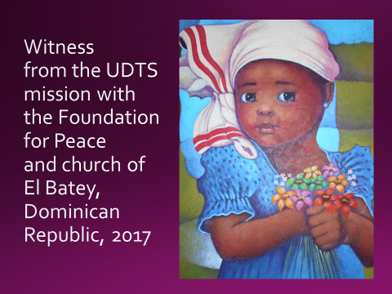

August, 2017

Friends of the Wendt Center,
In the spring of 2017, the University of Dubuque answered a call from the Foundation for Peace to send a return mission team to the Dominican Republic. This group of nine college and seminary students and staff shared worship, witness, encouragement, service and the beginnings of the development of a community center with the town of El Batey. El Batey is isolated by poor roads and a washed out bridge, challenged by poverty, but full of hope for growth, service, and witness. The mission provided two days of VBS for 75 children and a concluding fiesta for them and their families; a one-day medical clinic and medical staff to care for 50 families; 200 hygiene and new baby kits; thousands of dollars for materials and several days of shared work to begin building a community center; a week of shared worship in which UD contributed 3 days of preaching, testimonies and songs; fabric to sew new dance uniforms for the dance team of the El Batey Church; and a visit to the House of Light for children with disabilities. The greater offering has been in lives formed – the nine people sent by UD, the encouragement of the receiving community and the Foundation for Peace Staff, and the shared witness to God’s love in the D.R. and beyond. UD/UDTS alumna Kristin Hamner was field facilitator, and hundreds of people at UD and affiliated congregations and families have made up the “sending team.” It is a joy to provide this visual post-field report to you for your encouragement and information as you continue to pray for the receiving community of El Batey. Thank you to the Wendt Center for making this shared mission – and its ongoing fruitfulness – possible.
Yours in Christ –
Beth McCaw, Bridgett Boone, Krista Denne, Carl Jean, Maggie Lewis, Emily Sprunger, Wil Reinowski, Liz Swan and Tim McCaw
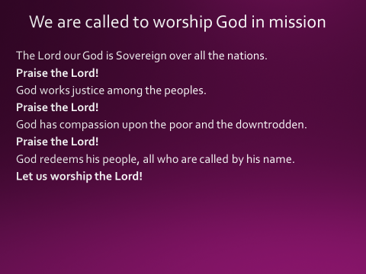

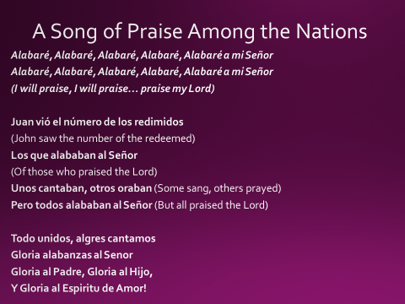
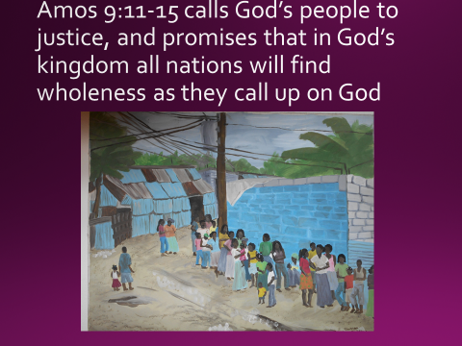

“In that day I will restore the fallen house of David.
I will repair its damaged walls.
From the ruins I will rebuild it
and restore its former glory.
¹² And Israel will possess what is left of Edom
and all the nations I have called to be mine.”
The Lord has spoken, and he will do these things.
¹³ “The time will come,” says the Lord,
“when the grain and grapes will grow faster
than they can be harvested.
Then the terraced vineyards on the hills of Israel
will drip with sweet wine!
¹⁴ I will bring my exiled people of Israel
back from distant lands,
and they will rebuild their ruined cities
and live in them again.
They will plant vineyards and gardens;
they will eat their crops and drink their wine.
¹⁵ I will firmly plant them there
in their own land.
They will never again be uprooted
from the land I have given them,”
says the Lord your God. (NLT)

