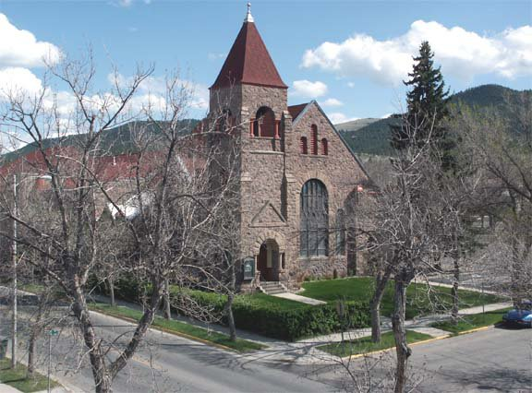

Big Sky Ministry Opportunity
Midway between Glacier and Yellowstone National Parks, First Presbyterian Church of Helena, Montana is seeking a full time installed solo pastor. Founded three years before the roaring Last Chance Gulch Gold Camp became Montana’s Territorial Capital, the historic First Presbyterian Church is a welcoming community of compassion, faith, and witness spreading the Good News of Jesus Christ through our love, words, and actions. We have been an active Matthew 25 church since 2021.

Helena is a great place for ministry and a wonderful place to live. Back country hikes, Alpine, Nordic and water skiing, an impressive symphony, blue ribbon trout streams, live theater, rodeos, art galleries and golf courses await you. To learn more, consider MDP 11104 at Church Leadership Connection (pcusa.org) and visit our website: www.fpchelena.org.

Questions answered here: pnchelenamt@gmail.com

